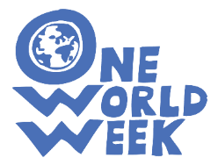
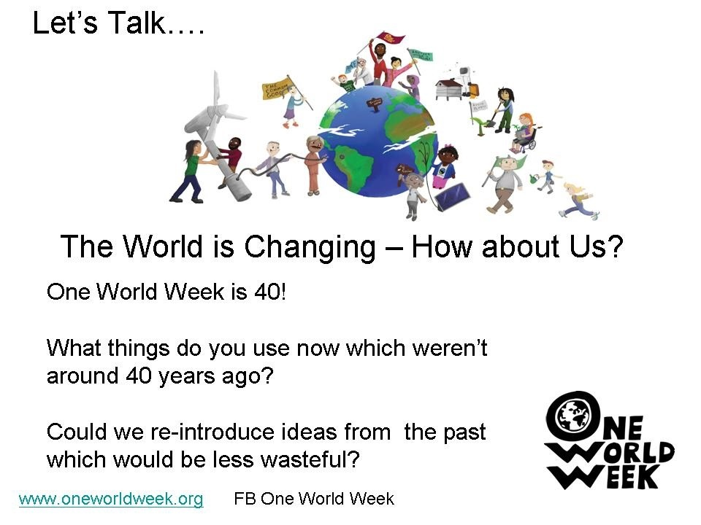

Discussion Starters
These have been designed to help people begin talking together about some of the issues raised in the OWW 2018 theme. They can be used with different audiences at various types of events from coffee mornings to parties to interfaith events. Or you could just leave them lying about in cafes and social areas! We thought the OWW is 40 one would be especially rewarding with mixed generations. We’d love to know you get on with these – so, please, let us know.
The OWW Resource Team
